**Lab: DOS Command Line Assignment Instructions**

**Overview**

The follow steps are a basic orientation to the command line and data networking. In this lab, you will access the command line in DOS and perform some basic commands that will systematically open some pathways into what really makes your computer, and network tick.

**Instructions**

Basic Requirement: taking screenshots is a basic skill you will need for this lab. If you do not know how to take a screenshot you should Google it and watch videos. There is an article showing 10 ways to take a screenshot titled “**Read: Screenshots in Windows 10 and Windows 11: 7 Easy Tricks**” found in the Learn section of Moduel 3: Week 3. I personally like the snipping tool.

**On to the Lab:**

**DOS Basics**

In the “Good Old Day” when we opened our computers, there was no welcoming screen—what we know as the Graphical User Interface (GUI—produced gooey). Instead, we were put into the operating system interface that looked something like this.

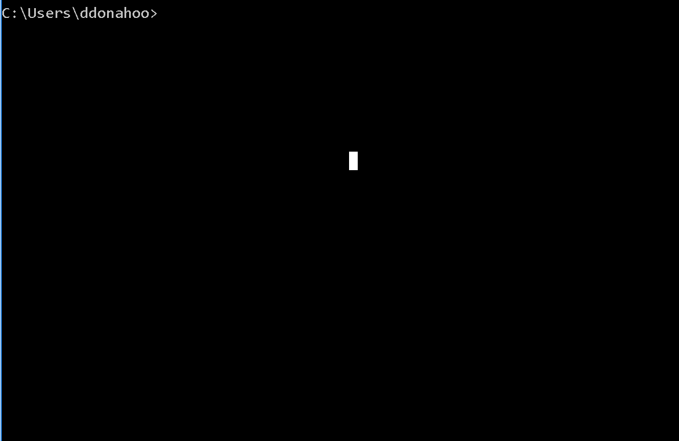

I believe it is very valuable, to our understanding of computers, to sometimes step back in time and do the things we commonly do in the GUIs of today, in the command line of yesterday. So this lab is built to give you an understanding of how to perform some common GUI tasks in the command line.You may even be surprised to see how command line (or DOS) reveals more information than the GUIs display.

1. **Date/Time Stamping (5 points)**

For you first exercise, you will learn how to put a Date/Time Stamp on your page. This is only first because every screenshot you complete during this lab will require a data/time stamp.

At the command line prompt type the following:

Time /t

Date /t

**Paste your Screen shot here (1 point):**

| Question 1 (2 points): What was the function of the /t switch in the command extension? | the /T switch which tells the command to just output the current time, without prompting for a new time. |
| --- | --- |
| Question 2 (2 points): How were you able to determine the function of the /t switch in the command extension | With the command:  Help Time |

1. **Command Line Help-1 (5 points)**

In the answer to question 2 above there is really no wrong way to get the right answer (other than to say that you just guessed). But, DOS does provide a very easy method. It is the embedded help command.

At the command line prompt type the following:

Help

Time /t

Date /t

**Paste your Screen shot here (1 point):**

| Question 3 (2 points): What does the Color command do? | Sets the default console foreground and background colors. |
| --- | --- |
| Question 4 (2 points): What does the DIR command do? | Displays a list of files and subdirectories in a directory. |

1. **Command Line Help-2 (5 points)**

To find out the syntax of a command you can type Help followed by the command you want. To demonstrate, let’s use the DIR command from Question 4.

At the command line prompt type the following:

Help DIR

Time /t

Date /t

**Paste your Screen shot here (1 point):**

| Question 5 (2 points): What does the /w function do? | **Uses wide list format.** |
| --- | --- |
| Question 6 (2 points): Try the DIR then the DIR /Q? What is the difference in the two outputs? | **Adds another column with owner of the file** |

1. **IpConfig (5 points)**

It is, at times, very helpful to know your basic IP information. You can see this on your computer by looking up the configuration.

At the command line prompt type the following:

ipconfig

Time /t

Date /t

**Paste your Screen shot here (1 point):**

| Question 7 (2 points): What is your IPV4 address (Use IPV6 if IPV4 does not show)? | 128.151.203.94 |
| --- | --- |
| Question 8 (2 points): What is the Address of your Default gateway? | 128.151.203.250 |

1. **Ping (5 points)**

Ping is a command that tells you if a host is reachable. It sends a packet and awaits for the reply, then tell you how long it takes. This allows you to diagnose latency or packet lost issues.

At the command line prompt type the following:

Ping *(insert your default gateway IP here)*

Ping google.com

Time /t

Date /t

**Paste your Screen shot here (1 points):**

| Question 9 (2 points): What were the time statistics (fill in the table)? | | | |
| --- | --- | --- | --- |
| **Destination** | **Maximum** | **Minimum** | **Average** |
| **Default Gateway** | 0 | 8 | 2 |
| **Google** | 9 | 9 | 9 |
| Question 10 (2 points): Why did google take longer than your default gateway? | | Because Google’s server is at a farther distance than my gateway | |

1. **Trace Route (5 points)**

While Ping gives you the traffic statistics, Trace Route will take you through the entire path to the destination.

At the command line prompt type the following:

Tracert google.com

Tracert google.com *(yes you need to complete 2 trace routes)*

Time /t

Date /t

**Paste your Screen shot here (1 point):**

| Question 11 (2 points): Did the trace route follow the exact same path in both traces? | No |
| --- | --- |
| Question 12 (2 points): If you saw variances in the two traces, explain why. If you did not, explain why you might see differences? | Because of network changes and trafficking protocols on routers. |

1. **Directory Task-1 (5 points)**

All of the director commands are now completed in the GUIs. But they all have their foundations in the DOS. For this task we will look at moving between directories. In the GUIs it is point and click first you look at the GUI version of the directory tree and click on the folder. Let’s fist look at the directory tree in DOS.

At the command line prompt type the following:

Tree *(wait for it to end—it will be longer than you are sue to seeing)*

Time /t

Date /t

**Paste your Screen shot here (1 point):**

| Question 13 (2 points): What did you notice about the tree structure in DOS? | It is every file directory on this machine |
| --- | --- |
| Question 14 (2 points): What can you appreciate about the GUI after seeing this? | I appreciate the faster time it takes to find folders |

1. **Directory Task-2 (5 points)**

Making a director in GUI is a task of selecting the folder and clicking on Add Folder. In DOS you need to move to the correct directory, then use the make directory command.

At the command line prompt type the following:

DIR /w

MD ABC-test

DIR /w

Time /t

Date /t

**Paste your Screen shot here (1 point):**

| Question 15 (2 points): Did you see your new directory on the second DIR? | Yes |
| --- | --- |
| Question 16 (2 points): Why or why not? | Because MD makes a directory |

1. **Directory Task-3 (5 points)**

Switching between directories is a simple task GUI it is not too much different in DOS if you know the commands with the exception of not being able to point and click of course.

At the command line prompt type the following:

CD ABC-Test

DIR /w

Time /t

Date /t

**Paste your Screen shot here (1 point):**

| Question 17 (2 points): How many files do you see in the new drive? | 0 |
| --- | --- |
| Question 18 (2 points): How is the prompt different after the change? | It adds ABC-test to the prompt |

1. **Directory Task-4 (5 points)**

Often, we need to remove directories as well. To do this, we use the remove directory command. Always be very careful as removing or deleting is permanent in DOS. Also, keep in mind that you cannot delete the directory if you are in it so you must change your directory before deleting. Try using CD .. that will back up out one level in the directory tree.

For this lab we are not going to have you remove the test folder. If you would like to do this on your own you can by going to the Windows Explorer and removing the folder.

| Question 19 (2.5 points): What DOS command would you use to remove the directory you just created? | rmdir |
| --- | --- |
| Question 20 (2.5 points): In brief words, what have you learned from this lab? | I learned about the translations from GUI to the command line and about the tools that the command line uses |

Submit the completed document through Assignment link in your course shell.